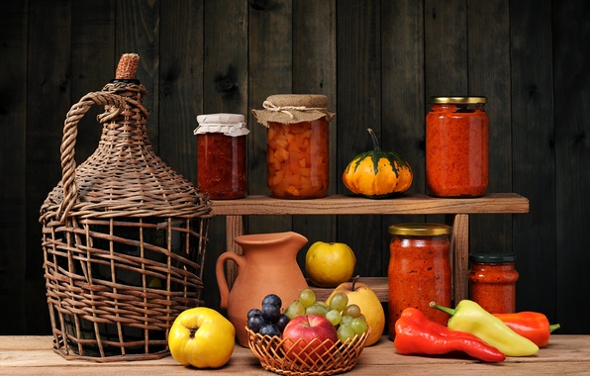
Quelle: https://img1.goodfon.ru/wallpaper/big/1/54/natyurmort-varene-frukty-ovoschi.jpg [31.8.18]

Quelle: https://www.pexels.com/photo/silver-imac-near-white-ceramic-kettle-205316/ [31.8.18]

Quelle: https://www.pexels.com/photo/business-chair-coffee-computer-265072/ [31.8.18]

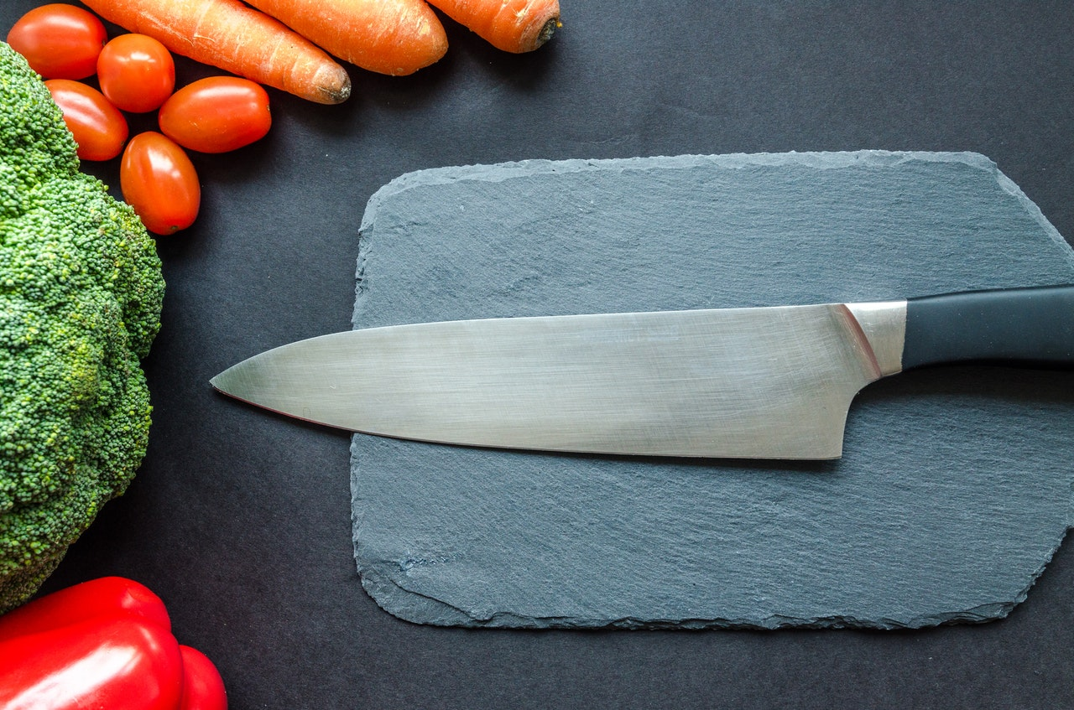
Quelle: https://www.pexels.com/de/foto/apfel-apple-aussicht-diat-952479/ [31.8.18]

Quelle: https://www.pexels.com/de/foto/becher-elektrik-elektronik-ipad-163187/ [31.8.18]

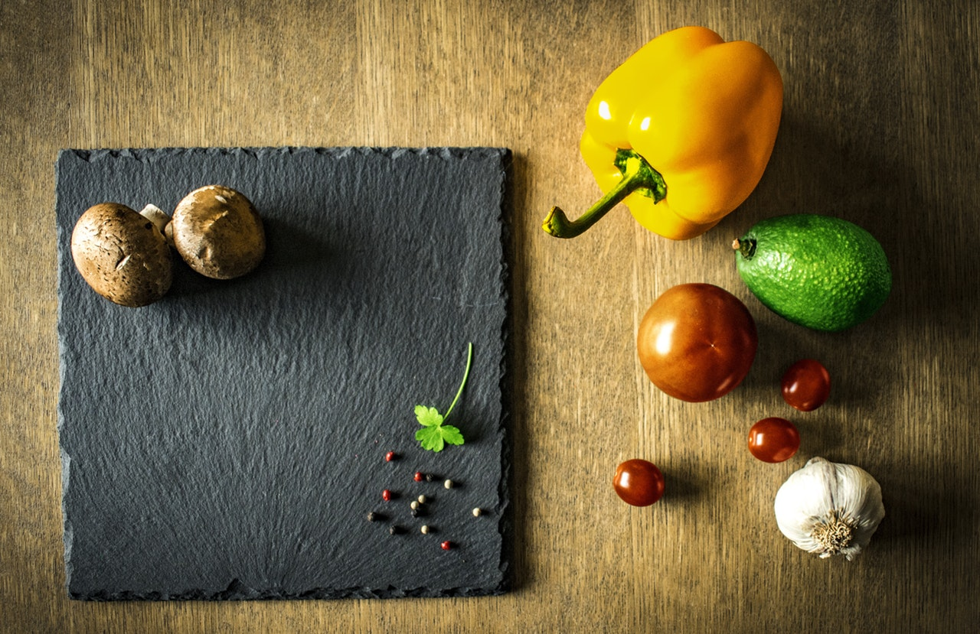
Quelle: https://www.pexels.com/photo/close-up-view-of-eggs-315737/ [31.8.18]

